Winning Scotland: Evaluation Partner
Winning Scotland seeks an evaluation partner to work on an exciting project, Mindset in Social Care.
About Winning Scotland
Winning Scotland is a charity that acts as a catalyst for change. Working with like-minded partners, we build confidence and resilience in all of Scotland's young people. In current times, the need for young people to possess these attributes has become more important than ever.
We are working across sectors to develop a culture where young people can thrive. The environment in which a child grows up has an overwhelming impact. Experiences at home, in school and in the community all leave a powerful imprint.
That’s why, with partners, we focus on supporting the people who have the biggest everyday influence on children and young people, like teachers and parents, empowering them with the skills and knowledge to support young people now and for many years to come.
This is highly sustainable, efficient and cost-effective. For example, a community with healthy lifestyle habits is more likely to achieve and be aspirational and a child with confidence and resilience is more likely to be successful in life.
About Mindset in Social Care
Following the successful impact of Winning Scotland’s Mindset Teams course in education, a case study from a care home in Dundee, identified that the content and approach of this type of growth mindset programme could also offer something very beneficial to those working with and supporting young people and families within the care system. The aim of this project is to re-imagine and re-design the Mindset Teams content, offering a programme specifically tailored to those working in the care system in Scotland.
The current context of the care system in Scotland is framed by the findings of the Care Review and the formation of the Promise. Growth mindset theory and approaches have the potential to support the implementation of the Promise. The principles of growth mindset align with the Foundations of the Promise, which challenge the use of ‘deficit language’ and state that families should be supported to “not feel judged”, “understand what they’re good at” and that children should “get all the help they need to learn and grow”. For those facing the challenges of implementing the Promise, a growth mindset approach also offers the belief that change, learning and growth are possible, and that challenges, setbacks and mistakes are part of the learning process and offer opportunities to develop reflective, flexible and creative practice in response.
Winning Scotland, in partnership with the Promise Partnership Fund and the Corra Foundation, are offering residential and care staff the opportunity to enrol on a course designed specifically to increase care staff's knowledge of growth mindset and in turn support young people to achieve all they can in life.
The Mindset in Social Care course will be accessible to as wide a range of those working within the care system as possible, with consideration given to those working in residential care home settings.

Course Content
The course content is based on increasingly clear research. The idea that we don’t have or can’t develop certain abilities; “I’ll never be able to play the piano” or “I’m not a maths person”. For most people, this is a myth, the reason isn’t because of some fundamental difference in our brains, it’s because of previous life experiences.
This content focuses on supporting young people to create a love of learning, recognise wider achievement, build self-belief, share best practice whilst strengthening relationships between young people and care staff.
Delivered over a 4-month period (Sept 2022 to January 2023), the course uses a mix of face-to-face seminars, supported with online learning.
- Seminar 1: Understanding growth mindset (Full day, face to face seminar)
- Seminar 2: Understanding mindset in a social care context (half day, online seminar)
- Seminar 3: Applying Growth Mindset in the Social Care Context (Full day, face to face seminar)
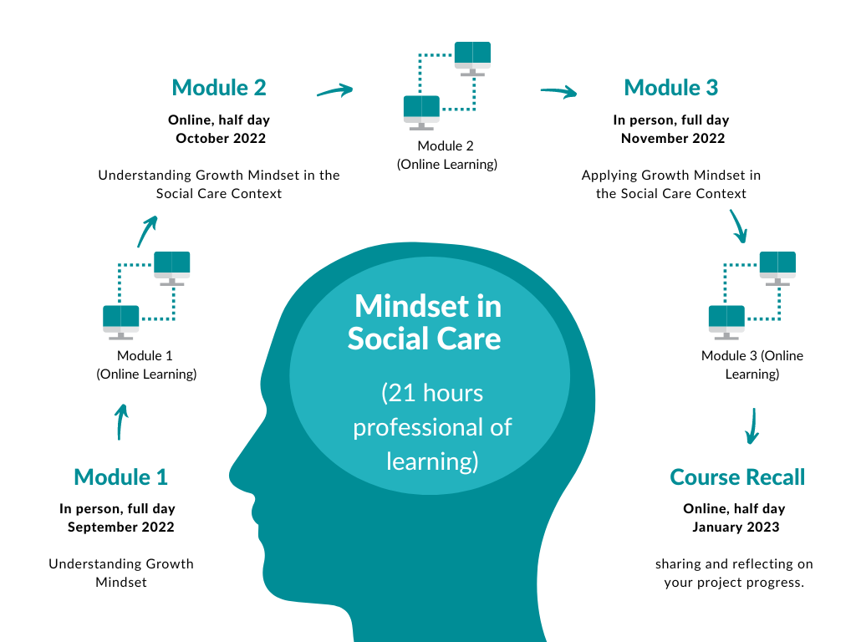
- Seminar 4: Course recall (half day, online seminar)

See appendix 1 for details of learning outcomes
Professional Development in Social Care
There is no single, unified training and development structure within the care system (unlike in education) due to the range of sectors and very varied roles involved. However, most organisations now recognise the importance of ongoing professional development and will encourage or require staff to engage in training and development opportunities as part of their annual Professional Development Plan (or equivalent). Some of the roles within the care system (for example social workers) now require a degree level qualification.
For all those roles requiring registration with the SSSC (most job roles in the social service sector), there is a Continuous Professional Learning (CPL) requirement in order to maintain registration. The requirement is set at the number of ‘learning hours’ rather than at a particular accredited level of learning. In most cases, learning hours can include private study, training courses, practice opportunities and a range of other activities. The number of hours required per year varies according to role, with the highest requirement for newly qualified social workers (NQSW). The SSSC signposts NQSWs to learning opportunities that they are aware of and has a dedicated site outlining the learning requirements for NQSWs. There is the potential for this programme to meet a number of these criteria.
For foster carers, there are no specific qualification requirements at present. The focus is more on assessment of suitability and then training and support. Organisations such as The Fostering Network provide training and learning opportunities for foster carers. It might be possible to link with organisations such as these to offer this programme to foster carers, particularly in relation to the implementation of the Promise. The Fostering Network (Scotland) for example has recently recruited a Promise Implementation Manager.
The Evaluation Partnership
The intention would be to establish a MOU between Winning Scotland and successful evaluation partner. The MOU would be subject to discussion, however, in order to establish the most suitable partner, you are asked to submit the following information:
- A brief background to your organisation and why you would be a good partner for Winning Scotland.
- What your organisation would hope to gain from working with Winning Scotland
- Brief overview of research team
- Expected time frames and associated costs
Outputs
Following the application process, the successful evaluation partner will be required to submit:
- an outline of the evaluation plans including partnership roles and responsibilities
- final evaluation report (due January 2023)
Through the evaluation partnership, Winning Scotland aim to:
- Establish key impact information from the Mindset in Social care course.
- Establish key findings to inform policy research and development, enabling influence of Scottish policy makers
- Develop a balanced viewpoint to inform the forward development of the programme.
- Establish and embed programme credibility

Mutual objectives from the evaluation partnership may include:
- Commitment to making life better for care experienced children and young people in Scotland.
- Potential influence on Scottish policy for care experienced children and young people.

Next steps
Interested evaluation partners are invited to submit a formal partnership proposal that outlines your organisation’s ability to work in partnership with Winning Scotland, establish findings, evaluate impact and importantly influence strategic policy at both local and national level in Scotland.
Partnership proposals should be submitted to Grant Small (grant@winningscotland.org), Winning Scotland, Director of Programmes and Impact, by 5pm on Friday 26 August 2022. We welcome joint or collaborative applications.

Appendix 1: Learning Outcomes
Learning Outcome 1: Demonstrate a critical understanding of growth mindset principles, concepts and theories, and how we might apply them to ourselves, our colleagues, young people and families, and the systems we work in.

Learning Outcome 2: Understand the connection between mindset theory and approaches to contexts (Care Review, Promise, Covid, mental health and wellbeing, voice).

Learning Outcome 3: Critical reflection on growth mindset applications in your own work context.

Learning Outcome 4: Demonstrate an understanding of how to connect mindset theory to the context of the Care Review and specifically the findings and recommendations of the Promise.

Learning Outcome 5: Consider how to apply growth mindset principles and techniques in order to support the workforce in the implementation of the Promise.

Learning Outcome 6: Consider how to utilise teamwork and bring others with you as you develop and plan your growth mindset project.

Learning Outcome 7: Share and review the impact of your Growth Mindset project.

